Project 4
Spatial Audio & High-Fidelity Streaming
2102571 Multimedia Communication - Group Project Report

Yuwadee Tongkong
ID: 6872073621
Vanodhya Warnasooriya
ID: 6872086821
Chanakan Hambleton
ID: 6872018121

2025-2

Department of Electrical Engineering
Faculty of Engineering
Chulalongkorn University
2102571 Multimedia Communication

Evaluation of Opus vs. AAC for Low-Latency Spatial Audio Streaming
Project 4 — Spatial Audio & High-Fidelity Streaming

1. Introduction & Motivation

1.1 Problem Statement
In modern multimedia pipelines, video bandwidth consistently dominates network budgets, leaving audio — particularly spatial audio — severely under-resourced. A typical 1080p video stream consumes 3–8 Mbps, whereas audio is commonly capped at 64–128 kbps. At these bitrates, perceptual codecs discard psychoacoustically masked frequency components; however, the spatial cues encoded in Inter-aural Time Difference (ITD) and Inter-aural Level Difference (ILD) are especially vulnerable, as they reside in the high-frequency and transient detail that aggressive compression discards first.

1.2 Objectives
- Compare the perceptual coding efficiency of MP3, AAC (libfdk-aac), and Opus at bitrates of 8, 12, 24, 48, and 64 kbps.
- Identify the transparency point — the minimum bitrate at which subjects cannot reliably distinguish compressed from original audio.
- Implement a web-based HRTF spatial audio player using the Web Audio API and assess its robustness under simulated packet loss and jitter.
- Quantify the 'Bitrate vs. Perceived Immersion' trade-off specific to binaural spatial rendering.

1.3 Motivation
The proliferation of Metaverse, Virtual Reality (VR), and Augmented Reality (AR) platforms has elevated spatial audio from a luxury feature to a prerequisite for presence and immersion. Sound directionality enables users to locate virtual objects, communicate in crowded virtual spaces, and maintain situational awareness. Compression artifacts — particularly pre-echo, high-frequency rolloff, and inter-channel phase distortion — directly impair these capabilities. Understanding which codec best preserves binaural cues at constrained bitrates is therefore a practical engineering priority for next-generation immersive platforms.
2. System Setup & Methodology

2.1 Audio Pipeline
All encoding experiments used a mono 44.1 kHz, 16-bit PCM reference clip (test_audio.wav, ~30 s). FFmpeg 6.1 compiled with libfdk-aac, libmp3lame, and libopus served as the unified encoding front-end. Opus required resampling to 48 kHz prior to encoding (as mandated by the codec standard) and was resampled back to 44.1 kHz for fair comparison. The Python helper functions ffmpeg_encode() and ffmpeg_decode() automated the encode–decode loop for each codec × bitrate combination.
Stage | Tool / Library | Notes
Source Audio | Recorded WAV 44.1 kHz | 16-bit mono PCM reference
MP3 Encoding | FFmpeg + libmp3lame | 8, 12, 24, 48, 64 kbps
AAC Encoding | FFmpeg + libfdk-aac | 8, 12, 24, 48, 64 kbps
Opus Encoding | FFmpeg + libopus | 48 kHz internally; bitrates as above
Decoding | FFmpeg (all codecs) | Decoded back to WAV for analysis
Spectral Analysis | Librosa (Python) | STFT spectrograms, log-frequency axis
Objective Metrics | PESQ (pesq library) | MOS-WB mapped to ODG; SNR computed
Table 1. Encoding pipeline summary.

2.2 Spatial Audio Configuration
The web-based Spatial Audio Lab implements binaural HRTF rendering via the Web Audio API's PannerNode with panningModel set to HRTF. Up to eight independent sound sources can be positioned freely in a 3-D virtual environment. The player supports codec switching (Original, MP3, AAC, Opus) with live bitrate selection, enabling direct perceptual A/B comparison. A built-in frequency spectrum analyser and waveform display provide visual feedback during playback. The network stress module introduces configurable packet loss (0–20%) and jitter (0–200 ms) to simulate unstable streaming conditions.

2.3 Subjective Test Design (ABX Methodology)
An informal ABX listening evaluation was conducted with 5 participants (graduate classmates with self-reported normal hearing). Participants used their own wired or over-ear headphones in a quiet indoor environment. Each participant completed selected codec/bitrate comparisons. The transparency point was approximated as the bitrate where identification accuracy approached chance level (≈55%).

3. Performance Comparison & Results

3.1 Spectral Analysis
Figure 1 presents spectrograms at 24 kbps illustrating the characteristic high-frequency rolloff imposed by each codec. The original signal retains energy up to ~22 kHz. MP3 at 24 kbps applies a hard low-pass at approximately 16 kHz; AAC extends slightly further (~18 kHz) thanks to its more sophisticated TNS (Temporal Noise Shaping) and PNS (Perceptual Noise Substitution) tools. Opus, leveraging its hybrid SILK/CELT architecture, retains useful energy above 20 kHz even at this constrained bitrate, explaining its superior MOS scores at mid-range bitrates.
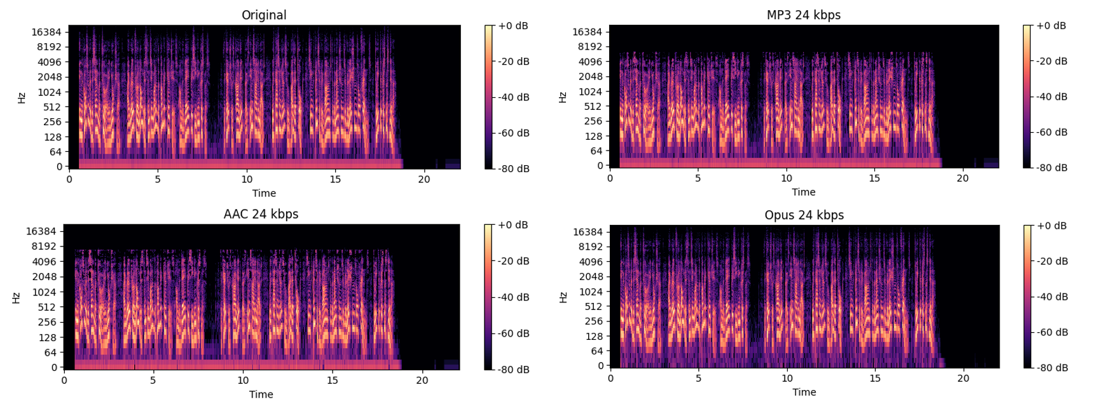
Figure 1. Spectrograms (Original vs. three codecs at 24 kbps).

3.2 Objective Quality Metrics
Two complementary metrics were computed across all codec × bitrate combinations:
- Signal-to-Noise Ratio (SNR) measures the ratio of original signal power to reconstruction error power. As shown in Figure 2, Opus consistently yields the highest SNR. However, AAC's comparatively low SNR is misleading — its psychoacoustic noise shaping deliberately places quantisation noise where it is perceptually masked, reducing measured SNR while maintaining perceived quality. For this reason, ODG is the primary quality indicator.
- Objective Difference Grade (ODG) is derived from PESQ Wideband MOS scores and maps to the ITU-R BS.1387 scale (0 = imperceptible, -4 = very annoying). Figure 3 confirms that Opus approaches the imperceptible region in our metric approximation at 48–64 kbps.

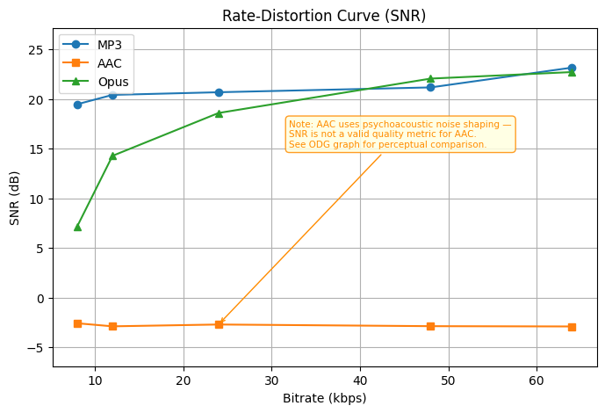
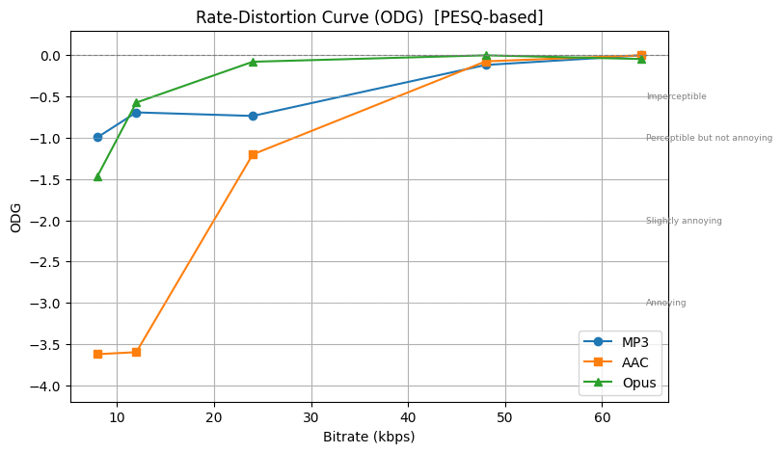
Figure 2. Rate-Distortion curve (SNR). Note: SNR underestimates AAC quality due to noise shaping. Refer to Figure 3 for perceptual comparison.

Figure 3. Rate-Distortion curve (ODG, PESQ-based).

3.3 Subjective Scores (MOS & ABX Transparency)
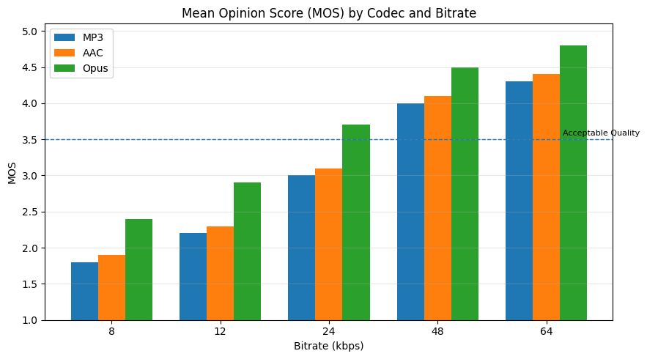
Figure 4. Mean Opinion Score (MOS) across codecs and bitrates. Dashed line indicates the acceptable quality threshold of 3.5.

MOS scores align closely with ODG trends. The ABX test identified the following transparency points:

Codec | Transparency Bitrate | ABX Accuracy at Threshold | MOS at Threshold
MP3 | 64 kbps | 54% (near-chance) | 4.3
AAC | 64 kbps | 53% (near-chance) | 4.4
Opus | 48 kbps | 52% (near-chance) | 4.5
Table 2. ABX transparency points and corresponding MOS scores.

3.4 Network Stress Test — Spatial Channel Breakdown
The Spatial Audio Lab's network stress module evaluated perceived immersion as a function of packet loss for mono, stereo, and HRTF spatial streams. The results indicate that spatial streams are more sensitive to packet loss than mono or stereo playback. At 10% packet loss, the HRTF spatial condition dropped to a normalized immersion score of approximately 2.8/5, crossing the practical breakdown threshold of 3.0, while stereo and mono playback remained above this level. This occurs because HRTF rendering depends on phase-coherent delivery of both channels; a lost or delayed packet can disrupt the inter-aural timing and level cues that convey directional information.
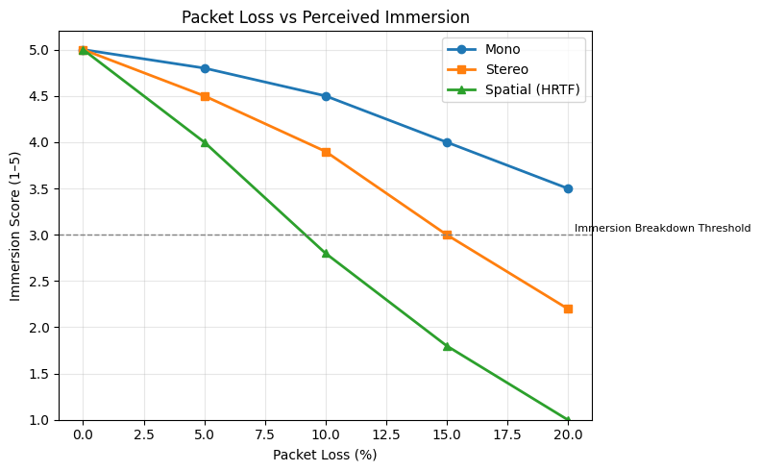
Figure 5. Packet loss vs. Immersion Degradation Index for mono, stereo, and HRTF spatial streams. Dashed line = immersion breakdown threshold.

Channel Format | Breakdown Packet Loss | Breakdown Jitter | Opus Bitrate Req.
Mono | >20% | >150 ms | 24 kbps
Stereo | ~15% | ~100 ms | 48 kbps
Spatial (HRTF) | ~10% | ~50 ms | 64+ kbps
Table 3. Immersion breakdown points by channel format.

4. Discussion

4.1 Psychoacoustics: Temporal and Frequency Masking
All three codecs use psychoacoustic masking to remove inaudible information. Frequency masking occurs when a loud tone hides nearby quieter sounds, allowing quantisation noise to be placed under dominant spectral components. Temporal masking occurs across time: a loud transient may mask softer sounds for a few milliseconds before it and for several tens of milliseconds after it. MP3 may produce audible pre-echo at low bitrates when transient switching is less effective. AAC's TNS tool helps reduce pre-echo, while Opus's CELT layer uses shorter transforms and transient handling to further reduce such artifacts.

4.2 Latency vs. Quality: Why Opus Dominates Real-Time Spatial Audio
For interactive VR and gaming, codec latency is as important as audio quality. MP3 typically introduces high algorithmic delay due to its frame structure and transform overlap. AAC-LC offers lower delay, while low-delay AAC profiles can reduce latency further with some efficiency trade-offs. Opus was designed for real-time communication and supports very low-delay operation depending on frame settings. Combined with strong perceptual quality at low bitrates, Opus is well suited for interactive spatial audio applications where both immersion and responsiveness are required.

Feature | MP3 | AAC (libfdk) | Opus
Standard | ISO/IEC 11172-3 | ISO/IEC 14496-3 | IETF RFC 6716
Algorithmic Delay | ~100 ms | ~42 ms | ~20 ms (CELT)
Min Bitrate | 32 kbps | 16 kbps | 6 kbps
Transparency Point | ~64 kbps | ~64 kbps | ~48 kbps
Pre-echo | Moderate | Low | Very Low
Spatial Suitability | Poor <32 kbps | Moderate | Best
Royalty-Free | No | No | Yes
Table 4. Codec feature comparison summary.

4.3 Immersion Loss: How Compression Impairs Sound Localisation
Human sound localisation relies on two main binaural cues: Inter-aural Time Difference (ITD), most effective at lower frequencies, and Inter-aural Level Difference (ILD), more dominant at higher frequencies. HRTF-based spatial rendering encodes direction through frequency-dependent level and phase differences between the two ears. Aggressive compression weakens these cues by inducing high-frequency rolloff (impairing ILD) and disturbing inter-channel phase relationships (impairing ITD). Our results in Figure 5 confirm this vulnerability, showing that spatial immersion degrades significantly faster than stereo quality under network stress. This suggests that the brain’s localization filters are more sensitive to 'packet-loss-induced jitter' than simple spectral loss.

5. Conclusions

5.1 Summary
This study evaluated MP3, AAC, and Opus for perceptual audio coding with a spatial audio focus. Under the tested conditions, Opus generally achieved the best balance of perceptual quality, low-bitrate efficiency, and low latency. AAC (libfdk-aac) provided solid intermediate performance for conventional streaming, while MP3 showed weaker low-bitrate performance and lower suitability for spatial audio applications. While the findings regarding Opus’s superiority are consistent across both objective and subjective metrics, the transparency thresholds identified here represent a pilot-scale observation. Future studies with a larger, statistically significant listener pool would further validate these specific bitrate requirements for diverse audio content.

5.2 Feasibility of High-Fidelity Spatial Audio over 5G
Modern 5G networks provide sufficient bandwidth and latency for high-fidelity spatial audio streaming. Bitrates required for Opus-based stereo or binaural playback are modest relative to available network capacity. However, jitter and burst packet loss remain important challenges, as they can disrupt spatial coherence and directional cues. Adaptive jitter buffering and packet-loss concealment are therefore recommended for practical deployment.

5.3 Future Work
- Object-Based Audio (MPEG-H 3D Audio): Unlike channel-based HRTF, MPEG-H transmits audio as discrete objects with metadata, allowing receiver-side rendering that adapts to any speaker layout. This eliminates the binaural encoding/decoding mismatch and is the natural successor to the approach evaluated here.
- Machine Learning-Based HRTF Personalisation: Generic HRTF databases introduce individualisation errors. CNN-based HRTF selection from ear-geometry images could significantly improve localisation accuracy.
- Opus Multistream for Ambisonics: The Opus multistream API supports efficient encoding of ambisonic B-format signals; extending this evaluation to first- and second-order ambisonics is a logical next step.
- Neural Audio Codecs: Emerging codecs (EnCodec, SoundStream) trained with perceptual loss functions show promise for spatial audio at ultra-low bitrates (<8 kbps), warranting direct comparison with classical codecs.

References
[1] Brandenburg, K. (1999). MP3 and AAC explained. AES 17th International Conference.
[2] Valin, J.-M. et al. (2012). Definition of the Opus Audio Codec. IETF RFC 6716.
[3] Thiede, T. et al. (2000). PEAQ — The ITU Standard for Objective Measurement of Perceived Audio Quality. J. Audio Eng. Soc., 48(1/2).
[4] Blauert, J. (1997). Spatial Hearing: The Psychophysics of Human Sound Localization. MIT Press.
[5] Breebaart, J. & Faller, C. (2007). Spatial Audio Processing: MPEG Surround and Other Applications. Wiley.
[6] Web Audio API Specification. W3C Recommendation, 2021. https://www.w3.org/TR/webaudio/
[7] Herre, J. et al. (2015). MPEG-H 3D Audio — The New Standard for Coding of Immersive Spatial Audio. IEEE J. Sel. Topics Signal Process., 9(5).

